CENWP-OD-B 11 July 2022

MEMORANDUM FOR THE RECORD

SUBJECT: 22BON035 MFR AFF Lamprey Morts

On 11 July, Columbia River Inter-Tribal Fish Commission (CRITFC) Biologists notified Bonneville Project Biologists of two lamprey mortalities found on the valve 15 trash rack in the Adult Fish Facility (AFF). The fish were scanned for PIT tags, inspected, and returned to the river.

- Species – Pacific Lamprey (Entosphenus tridentatus)
- Origin – Unknown
- Length – Approximately 71.8 cm (top photo) and 62.2 cm (bottom photo)
- Marks and tags – None
- Marks and Injuries found on carcass – NA
- Cause and Time of Death – Unknown.
- Future and Preventative Measures – None
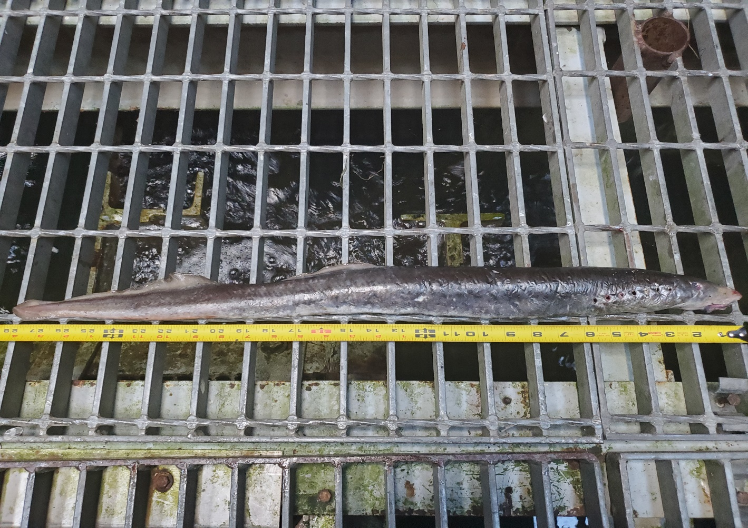
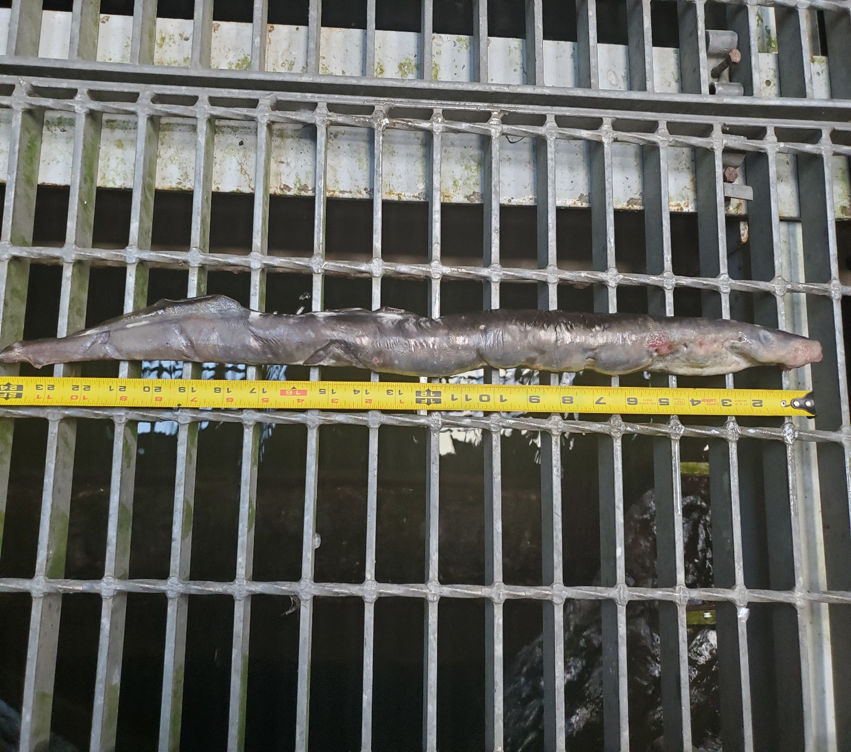
Sincerely,
Bonneville Project Fisheries

